Supplementary Material

Prognostic usefulness of clinical complete response after PD-1 inhibitor-based combination therapy for unresectable hepatocellular carcinoma (GUIDANCE006)
Liang Ma, Da-Long Yang, Teng-Meng Zhong, Qing-Qing Pang, Min Luo, Wen-Feng Li, Yi-He Yan, Kang Chen, Guo-Dong Wang, Fu-Quan Yang, Yong-Cheng Lai, Yao-Zhi Chen, Ming-Song Wu, Xiao-Feng Dong, Yong-Yu Yang, Ning Peng, Jun-Liang Nong, Ze Su, Ya-Qun Yu, Lin Ye, Fan-Jian Zeng, Shao-Ping Liu, Xue-Yao Wang, Hong-Bing Yao, Chuang Qin, Mian-Jing Li, Jie Liu, Yong-Rong Liang, Pei-Sheng Wu, Fu-Xin Li, Xian-Shuang Mao, Shu-Chang Chen, Jun-Jie Ou, Si-Cong Lu, Zhi-Cheng Li, Zhen Liu, Jia-Yong Su, Li-Xin Pan, Ping-Ping Guo, and Jian-Hong Zhong on behalf of the GUIDANCE investigators

Supplementary Methods
Method S1. Criteria for “unresectable” and “resectable” hepatocellular carcinoma in this study
To be considered unresectable, HCC had to meet at least one of the following criteria¹⁻³: (1) Eastern Cooperative Oncology Group performance status > 1; (2) diffuse HCC; (3) insufficient remnant functional liver volume after excision of all nodules; (4) indocyanine green retention rate ≥ 15% within 15 min; (5) presence of extrahepatic metastasis that could not be resected simultaneously with the primary tumor; (6) cancer thrombus involving the main portal vein and the contralateral branch of the portal vein, and/or cancer thrombus involving the inferior vena cava; (7) presence of other contraindications for hepatectomy.

To be considered resectable, HCC had to meet all the following criteria^{1,3}: (1) Eastern Cooperative Oncology Group performance status of 0 or 1; (2) sufficient remnant functional liver volume after excision of all nodules, defined as a remnant liver volume ≥ 30% of the standard liver volume in patients without cirrhosis or ≥ 40% of the standard liver volume in patients with cirrhosis; (3) indocyanine green retention rate < 15% within 15 min; (4) Child-Pugh liver function score of 5-7; (5) no cancer thrombus involving the main portal vein or portal vein branches on the lobe opposite the primary focus, and no cancer thrombus involving the inferior vena cava.

Method S2. The use of anti-angiogenic agents in this study
Lenvatinib (Eisai; Woodcliff Lake, NJ, USA) orally once a day, at a dose of 8 mg for individuals weighing less than < 60 kg or 12 mg for all others; donafenib (ZEPSUN®; Suzhou Zejing Biopharmaceutical, Suzhou, China) orally twice a day, at a dose of 0.2 g; apatinib (Jiangsu HengRui Medicine, Jiangsu, China) orally once a day, at doses of 250-500 mg; anlotinib (CTTQ PHARMA, Jiangsu, China) orally once a day, at a dose of 12 mg; or bevacizumab (Avastin; Shanghai Roche Pharmaceutical, Shanghai, China) intravenously once every three weeks, at a dose of 15 mg/kg; or sorafenib (Nexavar; Bayer, Leverkusen, Germany) orally twice a day, at a dose of 0.4 g.
Supplementary Tables
Supplementary Table 1. Regimens of PD-1 inhibitor-based combination therapy in this study.*
Component of combination therapy | n (%) of 1266 patients
Type of PD-1 inhibitor
Tislelizumab | 624 (49.3)
Sintilimab | 295 (23.3)
Camrelizumab | 235 (18.6)
Toripalimab | 112 (8.8)
Interventional therapy
Transarterial chemoembolization | 972 (76.8)
Hepatic arterial infusion chemotherapy | 294 (23.2)
Type of anti-angiogenic agent | n (%) of 892 patients
Lenvatinib | 625 (70.1)
Apatinib | 128 (14.3)
Donafenib | 56 (6.3)
Bevacizumab | 36 (4.0)
Anlotinib | 26 (2.9)
Sorafenib | 21 (2.4)
* All patients received at least one PD-1 inhibitor and interventional therapy.
Supplementary Table 2. Baseline demographic and clinical characteristics of patients who receiving lenvatinib and those receiving other anti-angiogenic agents.
Characteristic | Total (n = 892) | Lenvatinib group (n = 625) | Non-lenvatinib group (n = 267) | p | SMD
Sex |  |  |  | 0.182 | 0.100
Male | 789 (88.5) | 547 (87.5) | 242 (90.6)
Female | 103 (11.5) | 78 (12.5) | 25 (9.4)
Age, yr | 53.0±11.3 | 53.4±11.4 | 52.0±11.0 | 0.092 | 0.124
ECOG PS |  |  |  | 0.118 | 0.113
0 | 637 (71.4) | 456 (73.0) | 181 (67.8)
1 | 255 (28.6) | 169 (27.0) | 86 (32.2)
Hepatitis B virus surface antigen |  |  |  | 0.630 | 0.035
Negative | 186 (20.9) | 133 (21.3) | 53 (19.9)
Positive | 706 (79.1) | 492 (78.7) | 214 (80.1)
Antibody against hepatitis C virus |  |  |  | 0.255 | 0.079
Negative | 870 (97.5) | 612 (97.9) | 258 (96.6)
Positive | 22 (2.5) | 13 (2.1) | 9 (3.4)
Platelet count, ×10⁹/L | 206.0 (149.4, 270.8) | 214.0 (157.0, 289.0) | 197.0 (149.3, 256.4) | 0.007 | 0.206
Alanine aminotransferase, U/L | 40.0 (27.0, 60.8) | 40.6 (26.0, 64.0) | 39.1 (26.0, 57.5) | 0.447 | 0.148
Albumin-bilirubin grade |  |  |  | 0.557 | 0.043
1 | 300 (33.6) | 214 (34.2) | 86 (32.2)
2 | 592 (66.4) | 411 (65.8) | 181 (67.8)
Prothrombin time, sec | 12.7±1.9 | 12.8±1.9 | 12.6±1.7 | 0.237 | 0.088
Child–Pugh liver function |  |  |  | 0.406 | 0.061
A | 720 (80.7) | 500 (80.0) | 220 (82.4)
B | 172 (19.3) | 125 (20.0) | 47 (17.6)
α-fetoprotein, ng/ml |  |  |  | 0.428 | 0.058
< 400 | 429 (48.1) | 306 (49.0) | 123 (46.1)
≥ 400 | 463 (51.9) | 319 (51.0) | 144 (53.9)
Liver cirrhosis |  |  |  | 0.081 | 0.129
Absent | 336 (37.7) | 247 (39.5) | 89 (33.3)
Present | 556 (62.3) | 378 (60.5) | 178 (66.7)
Extrahepatic metastasis |  |  |  | 0.443 | 0.056
Absent | 683 (76.6) | 483 (77.3) | 200 (74.9)
Present | 209 (23.4) | 142 (22.7) | 67 (25.1)
Barcelona Clinic Liver Cancer stage |  |  |  | 0.629 | 0.070
A | 150 (16.8) | 101 (16.2) | 49 (18.4)
B | 273 (30.6) | 196 (31.4) | 77 (28.8)
C | 469 (52.6) | 328 (52.5) | 141 (52.8)
Maximum tumor diameter, cm | 9.3 (6.1, 12.3) | 9.5 (6.4, 12.2) | 9.4 (6.2, 12.3) | 0.982 | 0.011
Number of tumors |  |  |  | 0.501 | 0.049
Single | 339 (38.0) | 242 (38.7) | 97 (36.3)
Multiple | 553 (62.0) | 383 (61.3) | 170 (63.7)
Macrovascular invasion |  |  |  | 0.363 | 0.067
Absent | 514 (57.6) | 354 (56.6) | 160 (59.9)
Present | 378 (42.4) | 271 (43.4) | 107 (40.1)
Pathological complete response |  |  |  | 0.490 | 0.091
No | 170 (63.7) | 114 (62.3) | 56 (66.7)
Yes | 97 (36.3) | 69 (37.7) | 28 (33.3)
Values are n (%), mean ± standard deviation (SD), or median (interquartile range, Q₁, Q₃), unless otherwise noted.
ECOG PS, Eastern Cooperative Oncology Group Performance status; SMD, standardized mean difference.

Supplementary Table 3. Baseline demographic and clinical characteristics of patients who underwent hepatectomy, stratified by whether they achieved clinical complete response after PD-1 inhibitor-based combination therapy.
Characteristic | Total (n = 360) | Did not achieve complete response (n = 239) | Achieved complete response (n = 121) | p | SMD
Sex |  |  |  | 0.493 | 0.078
Male | 309 (85.8) | 203 (84.9) | 106 (87.6)
Female | 51 (14.2) | 36 (15.1) | 15 (12.4)
Age, yr | 51.3±10.6 | 50.5±10.6 | 52.9±10.5 | 0.038 | 0.234
ECOG PS |  |  |  | 0.136 | 0.164
0 | 284 (78.9) | 194 (81.2) | 90 (74.4)
1 | 76 (21.1) | 45 (18.8) | 31 (25.6)
Hepatitis B virus surface antigen |  |  |  | 0.350 | 0.103
Positive | 298 (82.8) | 201 (84.1) | 97 (80.2)
Negative | 62 (17.2) | 38 (15.9) | 24 (19.8)
Antibody against hepatitis C virus |  |  |  | 0.083 | 0.215
Negative | 355 (98.6) | 238 (99.6) | 117 (96.7)
Positive | 5 (1.4) | 1 (0.4) | 4 (3.3)
Platelet count, ×10⁹/L | 211.6 (164.8, 268.0) | 215.0 (165.3, 276.8) | 205.0 (156.0, 249.0) | 0.183 | 0.167
Total bilirubin, mol/L | 12.9 (9.6, 17.6) | 12.4 (9.4, 17.1) | 13.7 (9.6, 18.7) | 0.174 | 0.131
Albumin, g/L | 39.0±5.7 | 38.9±5.6 | 39.4±5.7 | 0.400 | 0.094
Alanine aminotransferase, U/L | 38.0 (27.0, 57.0) | 38.0 (27.0, 55.5) | 38.0 (26.0, 59.0) | 0.991 | 0.017
Prothrombin time, sec | 12.3 (11.5, 13.2) | 12.4 (11.6, 13.2) | 12.2 (11.3, 13.2) | 0.098 | 0.102
Child–Pugh liver function |  |  |  | 0.662 | 0.049
A | 330 (91.7) | 218 (91.2) | 112 (92.6)
B | 30 (8.3) | 21 (8.8) | 9 (7.4)
α-fetoprotein, ng/ml |  |  |  | 0.058 | 0.214
< 400 | 198 (55.0) | 123 (51.5) | 75 (62.0)
≥ 400 | 162 (45.0) | 116 (48.5) | 46 (38.0)
Liver cirrhosis |  |  |  | 0.233 | 0.133
Absent | 148 (41.1) | 93 (38.9) | 55 (45.5)
Present | 212 (58.9) | 146 (61.1) | 66 (54.5)
Extrahepatic metastasis |  |  |  | 0.279 | 0.124
Absent | 318 (88.3) | 208 (87.0) | 110 (90.9)
Present | 42 (11.7) | 31 (13.0) | 11 (9.1)
Barcelona Clinic Liver Cancer stage |  |  |  | 0.059 | 0.265
A | 120 (33.3) | 70 (29.3) | 50 (41.3)
B | 123 (34.2) | 89 (37.2) | 34 (28.1)
C | 117 (32.5) | 80 (33.5) | 37 (30.6)
Maximum tumor diameter, cm | 8.8 (6.1, 11.7) | 9.0 (6.2, 11.9) | 8.5 (5.9, 11.0) | 0.268 | 0.109
Number of tumors |  |  |  | 0.023 | 0.256
Single | 187 (51.9) | 114 (47.7) | 73 (60.3)
Multiple | 173 (48.1) | 125 (52.3) | 48 (39.7)
Macrovascular invasion |  |  |  | 0.666 | 0.048
Absent | 261 (72.5) | 175 (73.2) | 86 (71.1)
Present | 99 (27.5) | 64 (26.8) | 35 (28.9)
Values are n (%), mean ± standard deviation (SD), or median (interquartile range, Q₁, Q₃), unless otherwise noted.
ECOG PS, Eastern Cooperative Oncology Group Performance status; SMD, standardized mean difference.

Supplementary Table 4. Univariable and multivariable Cox regression to identify factors associated with survival in patients who underwent hepatectomy after PD-1 inhibitor-based combination therapy.
Factor | Univariable analysis |  |  | Multivariable analysis
Factor | Hazard ratio | 95%CI | p | Hazard ratio | 95%CI | p
Overall survival
Clinical complete response (present vs absent) | 0.17 | 0.07-0.43 | < 0.001 | 0.17 | 0.07-0.43 | < 0.001
Age (< 60 vs ≥ 60 yr) | 1.34 | 0.64-2.81 | 0.444
Sex (male vs female) | 0.95 | 0.47-1.91 | 0.875
ECOG PS (0 vs 1) | 0.98 | 0.52-1.85 | 0.959
Hepatitis B virus infection (absent vs present) | 0.88 | 0.42-1.85 | 0.736
Liver cirrhosis (absent vs present) | 0.75 | 0.45-1.26 | 0.274
Alanine aminotransferase (≤ 40 vs > 40 U/L) | 0.71 | 0.43-1.15 | 0.162
Prothrombin time (> 13 vs ≤ 13 sec) | 1.89 | 1.02-3.48 | 0.043 | 1.92 | 1.04-3.53 | 0.037
Platelet count (≥100 vs <100 ×10⁹/L) | 0.70 | 0.28-1.74 | 0.436
Child-Pugh liver function (A vs B) | 0.51 | 0.25-1.05 | 0.066
α-fetoprotein (<400 vs ≥400 ng/ml) | 0.95 | 0.57-1.94 | 0.796
Maximum tumor diameter (< 10 vs ≥10 cm) | 0.79 | 0.48-1.30 | 0.353
Tumor number (single vs multiple) | 0.81 | 0.50-1.33 | 0.413
Macrovascular invasion (absent vs present) | 0.73 | 0.44-1.24 | 0.247
Extrahepatic metastasis (absent vs present) | 0.62 | 0.33-1.16 | 0.131
Combination (TACE vs HAIC) | 1.15 | 0.92-1.44 | 0.227
Combined with anti-angiogenic agents (yes vs no) | 0.87 | 0.71-1.06 | 0.159
Recurrence-free survival
Clinical complete response (present vs absent) | 0.38 | 0.23-0.62 | < 0.001 | 0.20 | 0.14-0.29 | < 0.001
Age (< 60 vs ≥ 60 yr) | 1.62 | 0.85-2.96 | 0.115
Sex (male vs female) | 1.07 | 0.61-1.88 | 0.811
ECOG PS (0 vs 1) | 1.05 | 0.64-1.70 | 0.860
Hepatitis B virus infection (absent vs present) | 0.49 | 0.26-0.94 | 0.033 | 0.91 | 0.74-1.12 | 0.375
Liver cirrhosis (absent vs present) | 0.78 | 0.53-1.15 | 0.208
Alanine aminotransferase (≤ 40 vs >40 U/L) | 1.09 | 0.75-1.59 | 0.657
Prothrombin time (≤13 vs >13 sec) | 0.75 | 0.51-1.11 | 0.148
Platelet count (≥100 vs <100 ×10⁹/L) | 0.75 | 0.36-1.54 | 0.435
Child-Pugh liver function (A vs B) | 0.74 | 0.39-1.43 | 0.374
α-fetoprotein (<400 vs ≥400 ng/ml) | 0.83 | 0.57-1.21 | 0.341
Maximum tumor diameter (<10 vs ≥10 cm) | 0.78 | 0.53-1.13 | 0.191
Tumor number (single vs multiple) | 0.64 | 0.44-0.94 | 0.022 | 0.73 | 0.62-0.86 | < 0.001
Macrovascular invasion (absent vs present) | 0.74 | 0.50-1.10 | 0.136
Extrahepatic metastasis (absent vs present) | 0.55 | 0.34-0.89 | 0.014 | 0.51 | 0.44-0.61 | < 0.001
Combination (TACE vs HAIC) | 0.74 | 0.61-0.90 | 0.002 | 0.68 | 0.57-0.84 | < 0.001
Combined with anti-angiogenic agents (yes vs no) | 1.01 | 0.85-1.19 | 0.946
ECOG PS, Eastern Cooperative Oncology Group Performance status; CI, confidence interval.

Supplementary Table 5. Comparison of adverse events related to PD-1 inhibitor-based combination therapy in the entire cohort, stratified by whether they achieved clinical complete response after PD-1 inhibitor-based combination therapy.
 | Total (n = 1266) |  | Achieved complete response (n = 200) |  | Did not achieve complete response (n = 1066) |  | p *
Adverse event | Any grade | Grade 3 or 4 | Any grade | Grade 3 or 4 | Any grade | Grade 3 or 4 | Any grade | Grade 3 or 4
Abdominal pain | 234 (18.5) | 30 (2.4) | 38 (19.1) | 8 (4.2) | 196 (18.4) | 22 (2.1) | 0.837 | 0.162
Fever | 234 (18.5) | 86 (6.8) | 37 (18.3) | 11 (5.6) | 197 (18.5) | 75 (7.0) | 0.995 | 0.428
Fatigue | 247 (19.5) | 91 (7.2) | 36 (18.2) | 11 (5.5) | 211 (19.8) | 80 (7.5) | 0.557 | 0.314
Abnormal liver function | 210 (16.6) | 35 (2.8) | 35 (17.7) | 7 (3.6) | 175 (16.4) | 28 (2.6) | 0.705 | 0.489
Skin rash | 233 (18.4) | 56 (4.4) | 33 (16.4) | 11 (5.6) | 200 (18.8) | 45 (4.2) | 0.449 | 0.420
Hypertension | 206 (16.3) | 43 (3.4) | 31 (15.5) | 10 (5.1) | 175 (16.4) | 33 (3.1) | 0.747 | 0.172
Hand–foot skin reaction | 219 (17.3) | 48 (3.8) | 29 (14.3) | 6 (2.8) | 190 (17.8) | 42 (3.9) | 0.254 | 0.523
Decreased appetite | 153 (12.1) | 69 (5.5) | 27 (13.6) | 6 (3.2) | 126 (11.8) | 63 (5.9) | 0.504 | 0.096
Thrombocytopenia | 138 (10.9) | 55 (4.3) | 25 (12.7) | 4 (2.0) | 113 (10.5) | 51 (4.8) | 0.429 | 0.076
Nausea | 137 (10.8) | 42 (3.3) | 25 (12.4) | 5 (2.4) | 112 (10.5) | 37 (3.5) | 0.405 | 0.482
Anemia | 161 (12.7) | 26 (2.1) | 21 (10.7) | 3 (1.7) | 140 (13.1) | 23 (2.2) | 0.305 | 0.741
Insomnia | 145 (11.5) | 15 (1.2) | 20 (10.1) | 3 (1.7) | 125 (11.7) | 12 (1.1) | 0.482 | 0.926
Leukopenia | 83 (6.6) | 5 (0.4) | 17 (8.6) | 1 (0.9) | 66 (6.2) | 4 (0.4) | 0.226 | 0.577
Hypothyroidism | 123 (9.7) | 17 (1.3) | 15 (7.7) | 5 (2.6) | 108 (10.1) | 12 (1.1) | 0.249 | 0.224
Ascites | 89 (7.0) | 38 (3.0) | 11 (5.6) | 4 (2.2) | 78 (7.3) | 34 (3.2) | 0.356 | 0.366
Total adverse events | 1045 (82.5) | 190 (15.0) | 169 (84.5) | 27 (13.4) | 876 (82.2) | 163 (15.3) | 0.427 | 0.515
Values are n (%), unless otherwise noted. * Two-sided chi-squared test.
Supplementary Table 6. Characteristics and survival of patient cohorts with initially unresectable hepatocellular carcinoma who achieved complete response (CR) after conversion therapy.
 | Present study | Scheiner et al ⁴
No. patients | 200 | 77
Therapeutic regimen | PD-1 inhibitor-based combination therapy | Immunotherapy-based systemic therapy
Criteria for assessing radiological CR | mRECIST | mRECIST
Type of CR | Clinical CR | Radiological CR
BCLC stage A/B/C, n (%) | 72 (36.0)/62 (31.0)/66 (33.0) | 2 (3)/16 (21)/59 (77)
Macrovascular invasion, n (%) | 58 (29.0) | 29 (38)
Extrahepatic metastasis, n (%) | 21 (10.5) | 27 (35)
Curative conversion therapy performed, n (%) | 121 (60.5) | 11 (14)
Pathological complete response, n (%) | 95 (78.5) | 6 (54.5)
Time to complete response, median (95% CI) | 3.8 (2.7–4.9) | 6.8 (5.3–8.4)
Median follow-up, months | 22.5 | 32.2
Overall survival at 1, 2 and 3 years | 97.4%, 94.1%, 82.4% | 96.0%, 91.0%, 86.0%
Progression-free survival at 1, 2 and 3 years | 90.3%, 79.0%, 63.6% | 78.0%, 58.0%, 55.0%
Duration of CR, median (IQR), weeks | 7.6 (4.7-14.3) | Not applicable
Overall survival at 1, 2 and 3 years of patients who achieved cCR and did not subsequently undergo hepatectomy | 96.1%, 90.3%, 71.8% | Not applicable
Progression-free survival at 1, 2 and 3 years of patients who achieved cCR and did not subsequently undergo hepatectomy | 92.0%, 82.6%, 64.7% | Not applicable
cCR, clinical complete response; BCLC, Barcelona Clinic Liver Cancer; IQR, interquartile range; CI, confidence interval.
Supplementary Figures
Supplementary Figure 1. Comparison of (A) overall survival and (B) progression-free survival across the entire cohort, stratified by type of PD-1 inhibitor in PD-1 inhibitor-based combination therapy. HR, hazard ratio; CI, confidence interval.
Supplementary Figure 2. Kaplan-Meier curves of (A) overall survival and (B) progression-free-free survival in the subset of patients receiving lenvatinib and those receiving other anti-angiogenic agents. CI, confidence interval.

Supplementary Figure 3. Kaplan-Meier curves showing overall survival (OS) and progression-free survival (PFS) in the entire cohort.
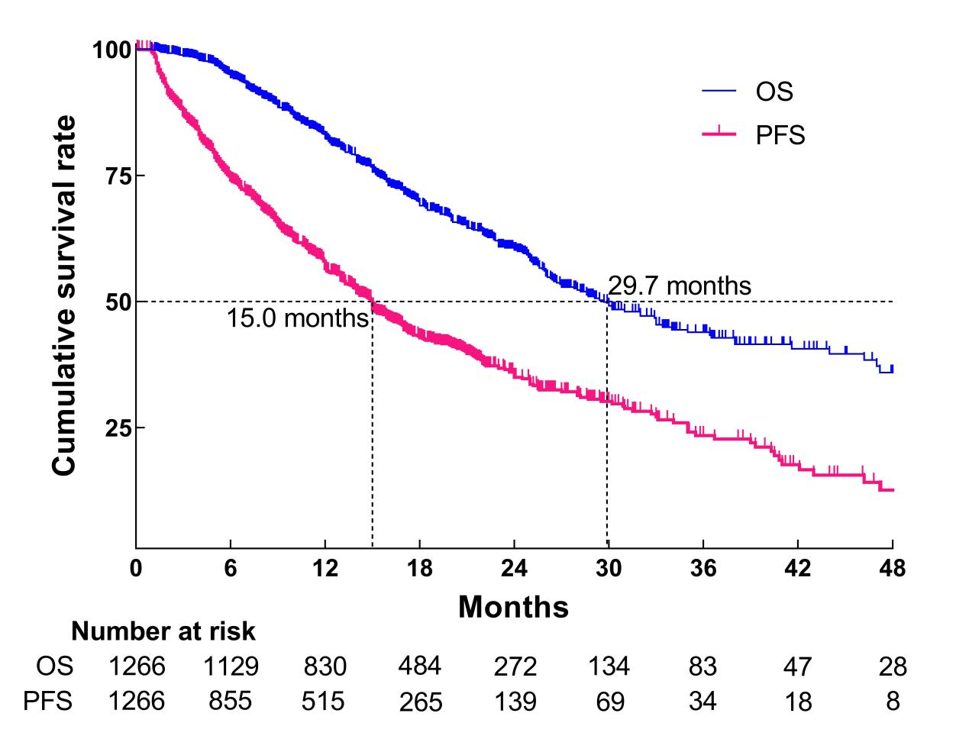

Supplementary Figure 4. Forest plots comparing (A) overall or (B) progression-free survival between patients who achieved clinical complete response (cCR) or not after PD-1 inhibitor-based combination therapy. CI, confidence interval; TACE, transarterial chemoembolization.
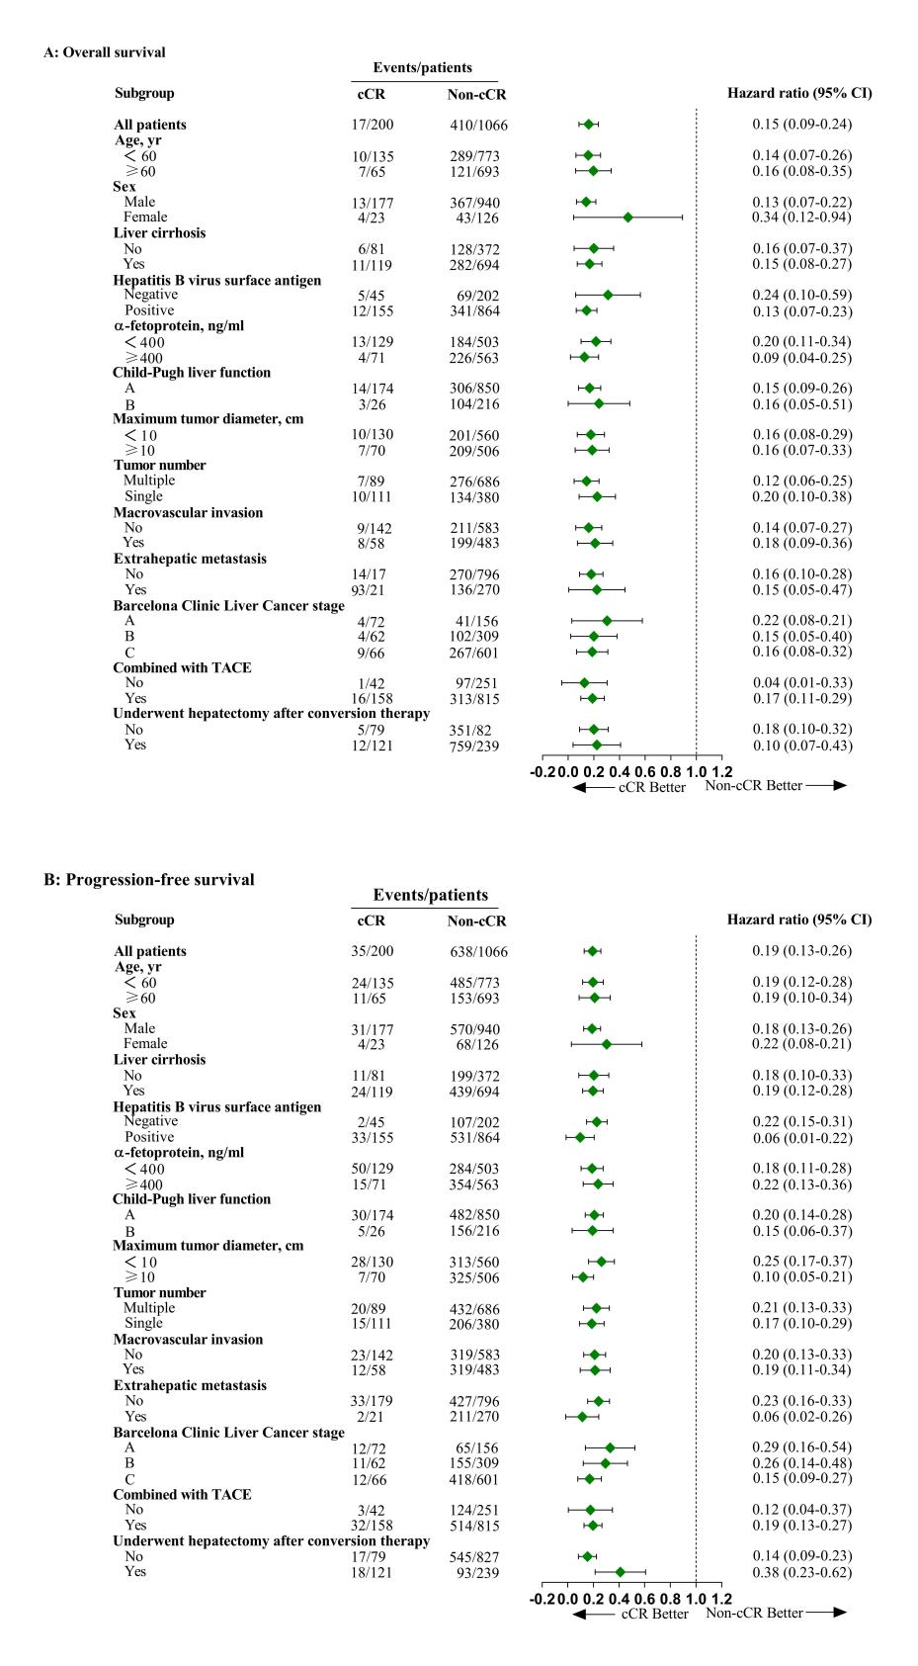

Supplementary Figure 5. Comparison of (A, C) overall survival and (B, D) progression-free survival between patients who achieved clinical complete response (cCR) or not after PD-1 inhibitor-based combination therapy involving transarterial chemoembolization (TACE) or hepatic artery infusion chemotherapy (HAIC).

Supplementary Figure 6. Comparison of (A) overall survival and (B) progression-free survival between patients who achieved clinical complete response (cCR) or not after interventional therapy combined with PD-1 inhibitors and anti-angiogenic agents. CI, confidence interval.
Supplementary Figure 7. Kaplan-Meier curves of (A) overall and (B) progression-free survival for the subset of patients who achieved clinical complete response to PD-1 inhibitor-based combination therapy but did not undergo hepatectomy. Patients were stratified into three groups based on the reasons for not undergoing hepatectomy: physician-advised abservation, patient-related concerns, and liver-related limitations. CI, confidence interval; HR, hazard ratio.
Supplementary Figure 8. Kaplan-Meier curves of (A, C) overall survival and (B, D) progression-free survival for subsets of patients whose disease was in Barcelona Clinic Liver Cancer (BCLC) stage A/B or C, stratified by whether they achieved clinical complete response (cCR) after PD-1 inhibitor-based combination therapy. CI, confidence interval; NA, not applicable.

Supplementary Figure 9. Landmark Kaplan-Meier survival analysis of (A, C) overall survival and (B, D) progression-free survival at landmark times of 5 or 7 months in the entire cohort, stratified according to whether they achieved clinical complete response (cCR) after PD-1 inhibitor-based combination therapy. CI, confidence interval; HR, hazard ratio.

Supplementary Figure 10. Landmark Kaplan-Meier survival analysis of (A-B, E-F) overall survival and (C-D, G-H) progression-free survival at landmark times of 5 or 7 months in the entire cohort, stratified according to whether they achieved clinical complete response (cCR) after PD-1 inhibitor-based combination therapy and according to whether their disease at baseline was Barcelona Clinic Liver Cancer (BCLC) stage A/B or C. CI, confidence interval; NA, not applicable.
Supplementary Figure 11. Sankey diagrams of changes in Barcelona Clinic Liver Cancer stage in the entire cohort (A). Kaplan-Meier curves comparing (B) overall survival or (C) progression-free survival between patients whose disease stage improved and those whose disease stage deteriorated or remained unchanged following PD-1 inhibitor-based combination therapy. CI, confidence interval.

Supplementary Figure 12. Kaplan-Meier curves of (A) overall survival and (B) recurrence-free survival in the subset of patients with Barcelona Clinic Liver Cancer stage B/C disease who underwent hepatectomy after PD-1 inhibitor-based combination therapy. Patients were stratified by whether they achieved clinical complete response (cCR) after PD-1 inhibitor-based combination therapy. CI, confidence interval; HR, hazard ratio.
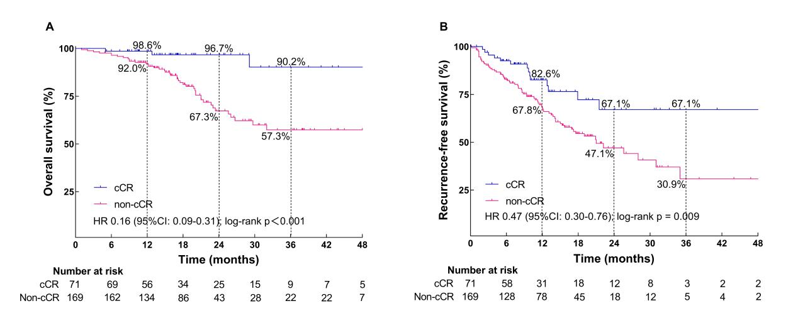

Supplementary Figure 13. Kaplan-Meier curves of (A) overall and (B) recurrence-free survival of the subset of patients who underwent hepatectomy after PD-1 inhibitor-based combination therapy. Patients were stratified according to whether surgical specimens indicated pathological complete response (pCR) or not (Non-pCR). CI, confidence interval; HR, hazard ratio.
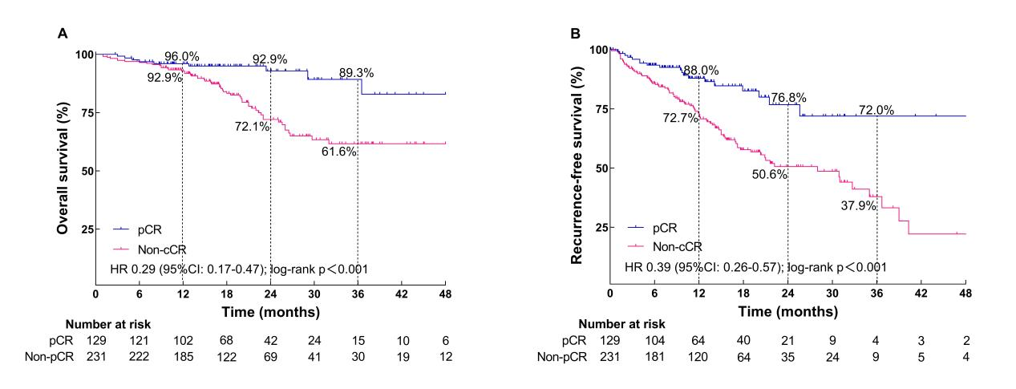

Supplementary Figure 14. Kaplan-Meier curves of (A) overall and (B) recurrence-free survival of the subset of patients who achieved clinical complete response after PD-1 inhibitor-based combination therapy. Patients were stratified according to whether surgical specimens indicated pathological complete response (pCR) or not (Non-pCR). CI, confidence interval; HR, hazard ratio.

Supplementary Figure 15. Proportions of patients who showed pathological complete response (Complete), major pathological response (Major) or non-major pathological response (Non-major) based on histopathology of surgical specimens taken during hepatectomy after PD-1 inhibitor-based combination therapy. Patients were stratified based on whether they achieved clinical complete response (cCR) after PD-1 inhibitor-based combination therapy.
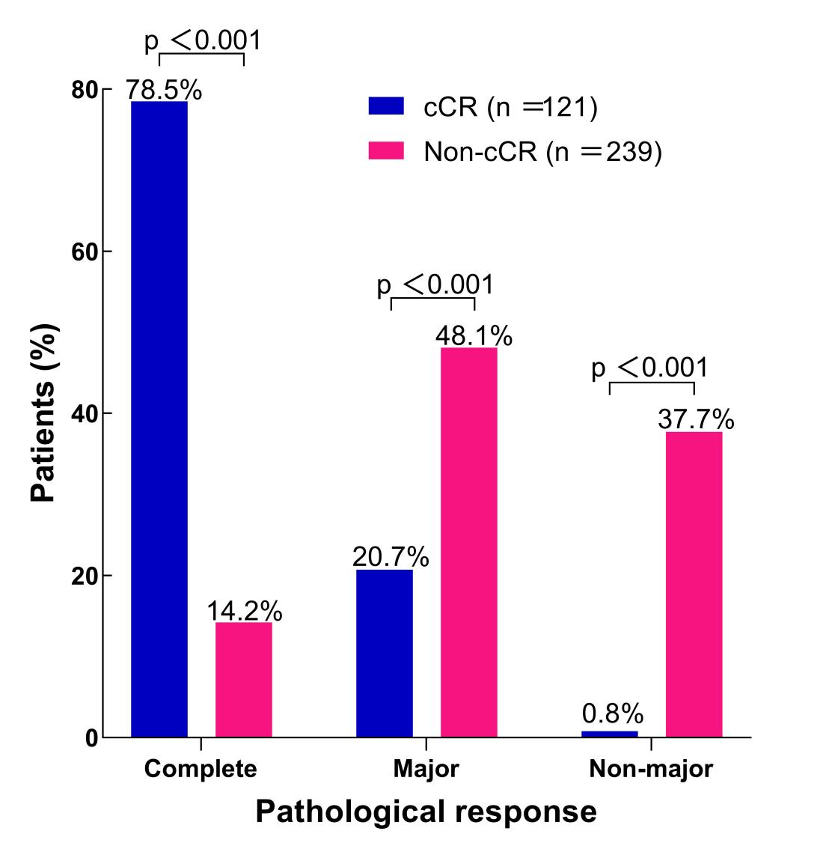

Supplementary Figure 16. Kaplan-Meier curves of (A) overall survival and (B) progression-free survival in the subset of patients who achieved clinical complete response to PD-1 inhibitor-based combination therapy. Patients were stratified by whether clinical complete response (cCR) persisted for shorter or longer than 6 months. Restricted cubic splines were utilized to evaluate the hypothesis of potential nonlinear relationships between duration of cCR and risk of overall survival (C) and progression-free survival (D). The Cox proportional hazards model was used to fit the data, with solid lines representing the estimated values and shaded areas representing the corresponding 95% CIs. The red dashed line represents the location of the inflection point in the curve. CI, confidence interval; HR, hazard ratio.
Supplementary references
1. Akahoshi K, Shindoh J, Tanabe M, et al. Oncological Resectability Criteria for Hepatocellular Carcinoma in the Era of Novel Systemic Therapies: The Japan Liver Cancer Association and Japanese Society of Hepato-Biliary-Pancreatic Surgery Expert Consensus Statement 2023. Liver Cancer. Dec 2024;13(6):0–10.
2. Zhou J, Sun H, Wang Z, et al. Guidelines for the Diagnosis and Treatment of Hepatocellular Carcinoma (2019 Edition). Liver Cancer. Dec 2020;9(6):682–720.
3. Ichida A, Arita J, Hatano E, et al. A Multicenter Phase 2 Trial Evaluating the Efficacy and Safety of Preoperative Lenvatinib Therapy for Patients with Advanced Hepatocellular Carcinoma (LENS-HCC Trial). Liver Cancer. Jun 2024;13(3):322–334.
4. Scheiner B, Kang B, Balcar L, et al. Outcome and management of patients with hepatocellular carcinoma who achieved a complete response to immunotherapy-based systemic therapy. Hepatology. 2025 Jun 1;81(6):1714-1727.

